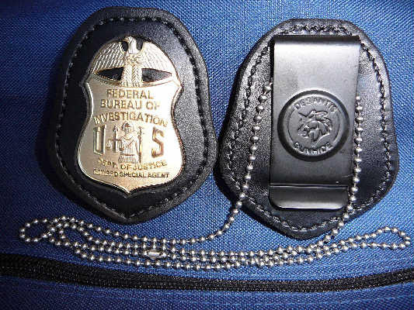
Photo: Retired FBI Badge mounted on the custom-made DeSantis belt-clip.

To order this badge and/or accessories Please Indicate Quantity of each item Requested:
Please mail check or money order to: Cost for badges: $80 each incl. Postage _______

L. Gandolfo
P.O. Box 230606 Cost for cred-badge cases & belt-clip badge holder:
Gravesend Station Belt Clip w/chain $30 each includes Postage ______
Brooklyn, NY 11223-0606 “A” Case w/Outside-Badge mount $40 each includes Postage ______

“B” Case w/Inside-Badge mount $50 each includes Postage ______

E-mail: LGFBI@JUNO.COM (NOTE: Prices include badge mounting, and all postage & handling)
Total amount enclosed: $ ______

Official Bu-Name:

Mailing Address:

E-mail: Phone(s):

Are you listed in the Society of Former FBI SAs Directory? (Yr / Pg #)

If not, please attach copy of your retired ID card or FBIAA card, and also fill in the following blanks:

Are you a retired FBI Special Agent? Years of Service: to

NAC: Office of Retirement: Credential Number:

Comments:

PLEASE NOTE:
BADGES ~ The 2½” retired badge is of high quality with fine detail. Metal content is 1.3 oz. of solid copper with a gold finish @ $80 incl. postage. Please use lawfully. Use authority guidelines are found in Title 18 USC Sect 716-b.

ACCESSORIES ~ All accessories are now being custom-manufactured by DeSantis Holster Co., of Long Island, NY.

CRED-BADGE CASES - Cases are made of high-quality black leather. There are two styles to choose from:
Style “A” ~ is a bi-fold with an outside badge cut-out, and sells for $40 (including badge-mounting, postage & handling).
Style “B” ~ is a bi-fold with a third flap accommodating six license/HR-218/credit card slots with an inside badge cut-out
and suede badge-cover flap, selling for $50 (including badge-mounting, postage & handling).

BELT-CLIP BADGE-HOLDER ~ Custom badge cutout, sturdy belt spring-clip, and a neck chain. Cost including badge-
mounting & shipping: $30. NOTICE: It is highly recommended that the belt clip & badge are ordered together. LGFBI is not responsible for damaged badge clasps when ordered separately and badge is mounted by customer.

MISC: When not back-ordered, upon receipt of your check or credit-card order, the badges and accessories will be promptly
mailed to you in the same or next day’s mail. Please make all checks payable to L.Gandolfo.
NOTE: Credit card payments will incur a surcharge as follows: $5 for any amount up to $100, then $1 for each additional $20
or part thereof. Please clearly indicate your credit card number, expiration date, security code, and billing zip code:

Card number: ______-______-______-______ Exp date: ___/___ Security code: _____ Billing Zip Code: __________

Website: WWW.LGFBI.COM ~ E-mail address for Ret. SA Lucian J. Gandolfo: lgfbi@juno.com

